Ideation Phase

Define the Problem Statements

|  |  |
| --- | --- |
| Date: | 18 June 2025 |
| Team ID: | LTVIP2025TMID36354 |
| Project Name: | Enchanted Wings: Marvels of Butterfly Species |
| Maximum Marks: | 2 Marks |

**Problem Statement (PS-1):**

**I am** a biodiversity researcher  
**I’m trying to** identify butterfly species during field research  
**But** I often lack fast, accurate references in the field  
**Because** printed identification guides are slow to use and manual classification is error-prone  
**Which makes me feel** frustrated, delayed, and worried about data accuracy

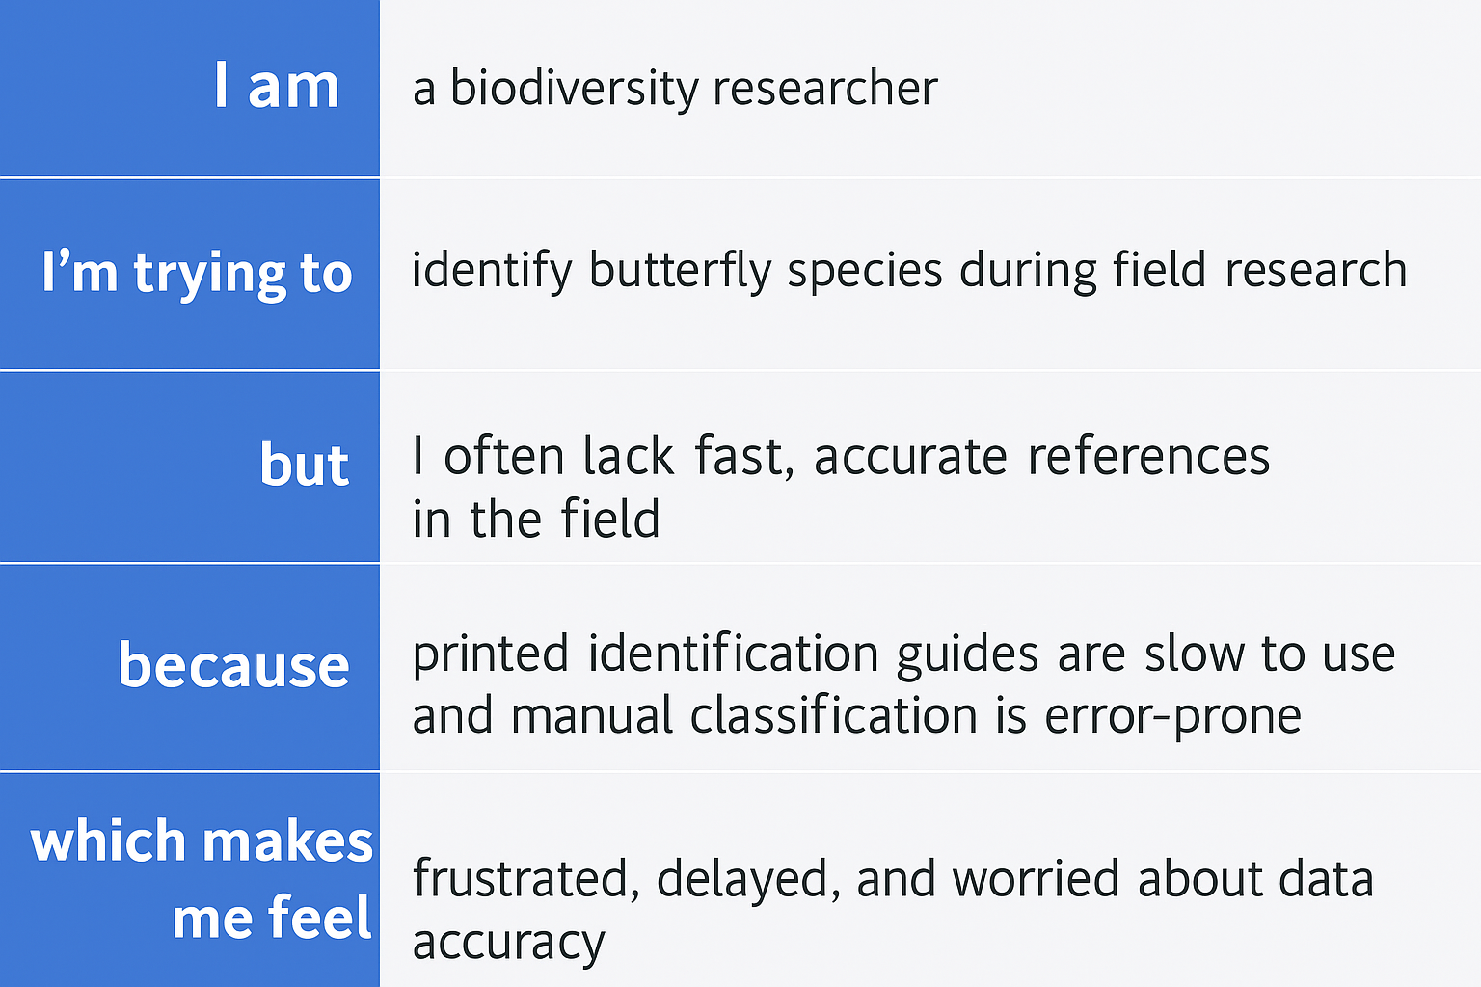

**Why This Matters**

Understanding these challenges allows the team to build an AI-powered solution  
that empowers users with real-time, accurate butterfly identification.  
This helps boost engagement, reduce errors, and supports conservation and research.